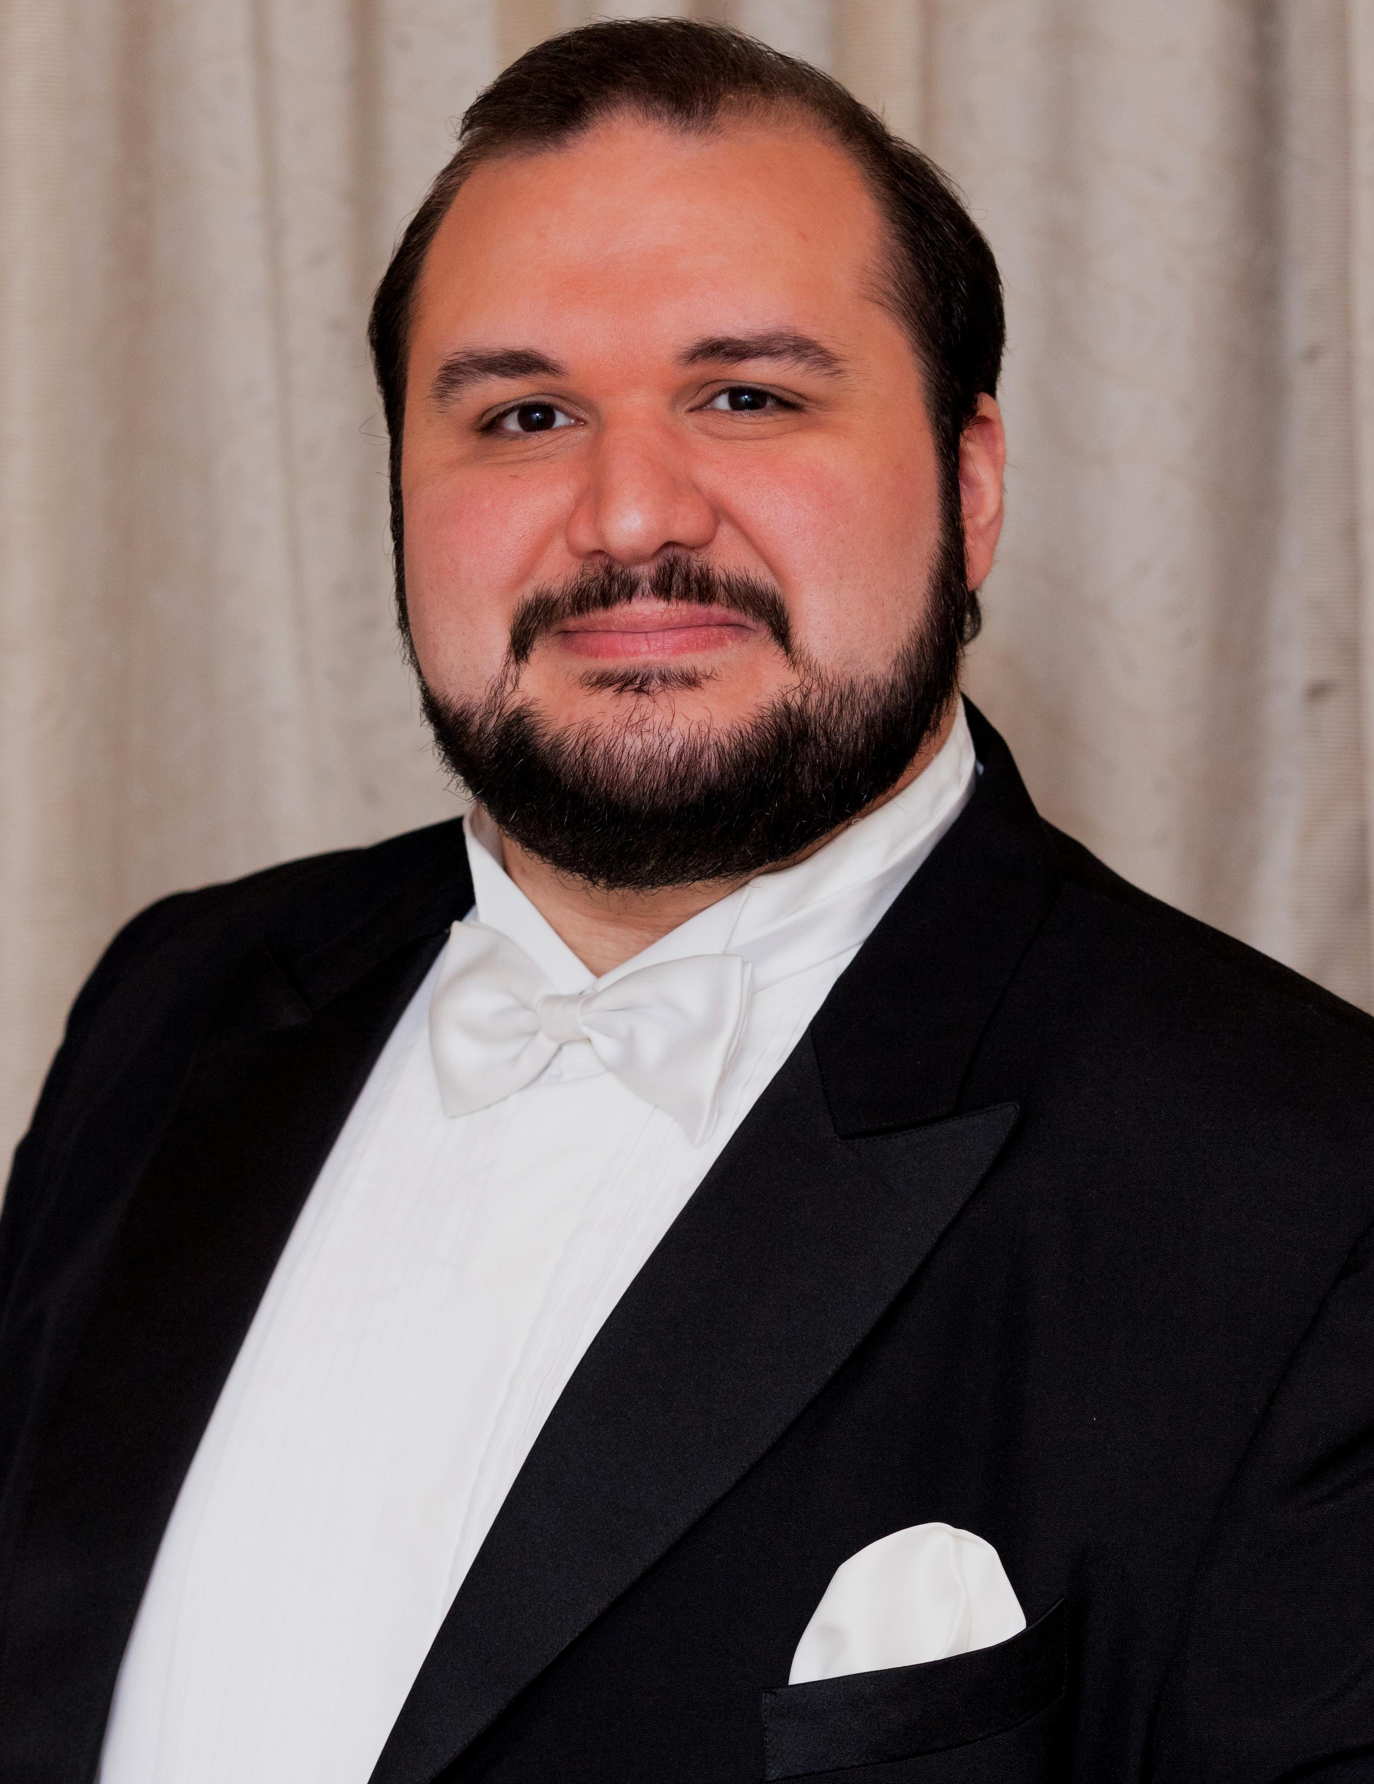
biography
lorenzo rositano
tenor

Lorenzo Rositano is known as one of Australia’s favourite Tenors.
Lorenzo’s concerts and cabaret performances are filled with warmth and humour. He also brings power and passion to his performances with some of the great Tenor repertoire from the popular Musical Theatre songs such as This is the Moment and The Impossible Dream, to the most well known Operatic arias such as La Donna è Mobile and Nessun Dorma, and the traditional Neapolitan songs such as Funiculì Funiculà and O Sole Mio.
Lorenzo Rositano is an Italianate Operatic Tenor who began singing at the age of 7. He studied in the UK, Italy and completed his studies in Australia at the Sydney Conservatorium of Music with a Masters in Opera.
Lorenzo has appeared as Principal Tenor in many Opera and Operetta roles as well as Soloist in Oratorio works and Recital around Australia and abroad.
Lorenzo made international headlines when he was selected by the Australian Olympic Committee to perform the Australian Anthem at the Winter Olympic Games in Turin, Italy.
Since Lorenzo’s return to Australia from Italy, he has made it his mission to bring Opera more regularly to Western Sydney. Consequently Lorenzo is the Founder & Artistic Director of Western Sydney Opera.

Education
2006/13/14 Private Tuition
Rome, Bologna and Turin
2011/12 Master of Music Studies, Opera
Sydney Conservatorium of Music
2010 Private Tuition
London
2007-2010 Advanced Diploma of Opera
Sydney Conservatorium of Music
2001-2006 Private Tuition
Joan Sutherland Performing Arts Centre, Penrith

Operatic Roles: Performed
2007 Ernesto: La Vera Costanza, HAYDN | Alcino: Prima Donna, BENJAMIN
2008 L’Italien: Angélique, IBERT | Alfred: Die Fledermaus, STRAUSS
2009 Le Journaliste: Les Mamelles de Tirésias, POULENC
The Mayor: Albert Herring, BRITTEN | Florville: Il Signor Bruschino, ROSSINI
2011 King Arthur: King Arthur, PURCELL | Contino Belfiore: La Finta Giardiniera, MOZART
2012 Prince Ali: Les Pèlerins de La Mecque, GLÜCK | Orphée: Orphée aux Enfers, OFFENBACH
2014/15/16 Rodolfo: La Bohème, PUCCINI | Nemorino: L’elisir d’amore, DONIZETTI
Operatic Roles: Studied (*Sections only)
2009/10 Italian Singer: Der Rosenkavalier, STRAUSS | *Ferrando: Così Fan Tutte, MOZART*
2012 *Tamino: Die Zauberflöte, MOZART*
2013/14 Alfredo: La Traviata, VERDI | Duca: Rigoletto, VERDI
Oratorios, Recitals and Concerts
2002/3/4/5/8 Soloist: ABC Schools Spectacular – Sydney Entertainment Centre
2007/9 Soloist: Messa di Gloria, PUCCINI – New Calédonia and Sydney
2007/10 Concerts: Taiko Drum Festival and Encore Vocal Group – Japan
2010 Soloist: Stabat Mater, ROSSINI – Sydney
2012/14 Soloist: Requiem, VERDI [Understudied] – Sydney and Italy
2012/13/17 Concerts: Lorenzo & Friends – Joan Sutherland Performing Arts Centre, Penrith
2006/13/14 Recitals: XX Olympic Winter Games Turin, Rome and Calabria – Italy

Competitions and Awards
2013/14 John Brown AO: Sport and Tourism Youth Foundation Scholarship – Tuition in Italy
2014 Competitions: Padua, Ferrara, Taormina, Verona, Busseto – Italy
2011/12 Finalist: New York Scholarship, Opera Foundation Australia
2011 Quarter Finalist: Operatic Aria, Sydney Eisteddfod
2011 Full Tuition: Postgraduate Scholarship, Sydney Conservatorium of Music
2010 Classical Music: BBM Youth Support Award – Tuition in England
Conductors Directors Teachers / Coaches
Imre Palló Stephen Mould Rachael Macdonald Matthew Barclay Barry Ryan Simon Kenway
Carolyn Watson Stephen Williams Brendan Carmody Fulvio Macciardi Maree Ryan Sharolyn Kimmorley
Cristian Cimei Plamen Tzontchev Narelle Yeo Trevor Brown Natalie Murray
Philip Chu Steve Watson Tom Healey Nicole Dorigo Dragana Moles
Christopher Bowen Daniele Moles John Milson Anke Höppner Glenn Amer
Sadaharu Muramatsu Evelino Pidò Sally Blackwood
Neal Peres Da Costa

